**Question 1: Write an SQL expression to select all counties whose names begin with the letter 'Q' (imagine you have a table called Counties with suitable attributes).**

SELECT county_name

FROM Counties

WHERE county_name LIKE ‘Q%’;

**Question 2, imagine you have a table of states and a table of airports, both with a state abbreviation field. Can you join them if states is the destination table? Can you join them if airports is the destination table? Explain why in a sentence for each.**

I may not join them if ‘states’ is the destination table – there are many airports located in each state, so this join would be a one-to-many relationship (one state has many airports) and violates the rule of joining. I can join them if ‘airports’ is the destination table, where I would have a many-to-one relationship (many airports to one state), which does not violate the rule of joining.

**Question 3**

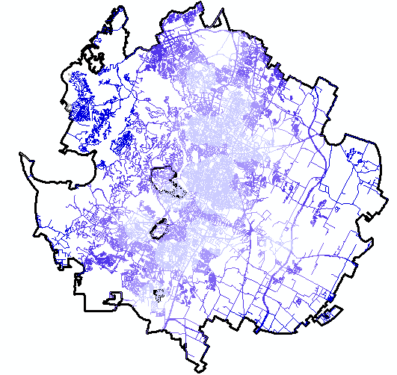

**Question 4**

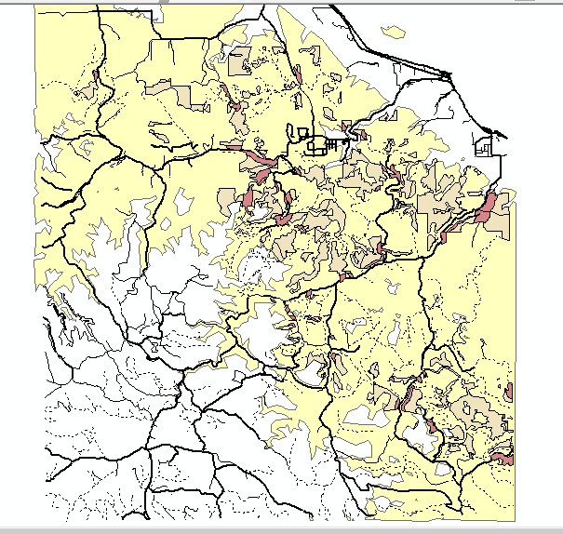

**Question 5: how many schools are within ‘at risk’ areas?**

272 schools in at-risk areas

**Question 6: What is the mean value (with units) that is generated from this operation?**

65527.639706 dollars

**Question 7: What is the mean value (with units) that is generated from this operation?**

75081.318885 dollars

**Question 8: Which is larger, the mean value for median income for at-risk schools, or all schools? What does this analysis let you say about how risk, schools, and income are related in King County? What sorts of conclusions can you not yet reach because you don’t have enough (or proper) evidence?**

**The mean value for median income for all schools is larger. Through this analysis, we may speculate that households with higher median incomes can afford to send their children to school outside of at-risk areas. However, we cannot be complete sure of this because households may send their children to different schools for different reasons - not just income.**

**Question 9: Make a single-page map that attempts to visualize the relationships within King County between schools in ‘at risk’ areas, those not in ‘at risk’ areas, and census tracts of various median family income levels.**

